


Masters in Data Science

Maths for Data Science


Maths for Data Science Portfolio

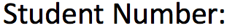
25141354


Ali Vaisifard


2805 Textual word count / Rest are Code Evidence in Appendix and Numerical Derivations required by Professor Banadaki in my Draft Report Comments.

Table of Contents
1 | Introduction | 3
2 | Part A: 1. Represent the System in Matrix Form | 3
3 | Part B: Calculus Analysis of Vehicle Speed and Acceleration | 6
4 | Part C: Probability Analysis of Autonomous Vehicle Reaction Times | 12
5 | Part D: Statistical Analysis of ISA Speed Compliance | 15
6 | Reflection | 18
7 | Comprehensive Evaluation | 18
8 | Conclusion | 20
9 | References | 20
10 | Appendix / Code Evidence Section | 21

Introduction
Urban Mobility Intelligence Unit (UMIU) - Traffic Flow Analysis
Urban traffic congestion costs the UK economy an estimated £8 billion annually, underscoring the urgent need for data-driven and mathematical approaches to improve traffic efficiency, safety, and sustainability in modern mobility systems (INRIX, 2023). This report investigates how mathematical techniques can be used to understand and optimize traffic behavior in a smart mobility environment in Manchester, particularly in relation to EV charging activity, autonomous vehicle response, and speed regulation. First, linear algebra will be applied to model and determine traffic flow equilibrium, then calculus will be used to analyze vehicle speed and acceleration patterns along a smart corridor, probability will be employed to assess uncertainty in autonomous vehicle reaction times, and finally, statistical methods will evaluate speed compliance within an ISA trial zone.

Part A: 1. Represent the System in Matrix Form
As part of the Urban Mobility Intelligence Unit (UMIU), I am tasked with analyzing steady-state traffic flow in Manchester, specifically how EV charging activity affects equilibrium traffic flows. I will apply linear algebra techniques to solve the given system of equations representing traffic flows along four key roads (with figure of coding below the text) (in the following assignment, I have opted for 2 methods for the solution, I have done mathematical calculations along with the python calculations for the process, reason being I had 2 teachers with approaches that were not similar, first teacher focused on the assignment being done using python with a detailed textual explanation, however, teacher number 2, who took a few classes at the end of our semester, instructed me in the comments of my draft report to add more mathematical derivations as well).
The traffic flow across a network of interconnected junctions is represented by the following set of linear equations:
2x1 - x2 + x3 = 150
x1 + x2 + x4 = 420
-x1 + 3x3 - x4 = 100
x2 + x3 + x4 = 380

Python Representation:
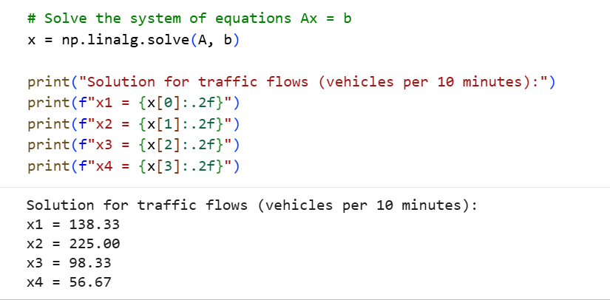

Where x1, x2, x3, x4 represent traffic flows (vehicles per 10 minutes) along four key roads.
1. The given system of equations can be written in matrix form as A x = b (Lay, McDonald and Lay, 2021)
Where:
A =
[ 2 -1 1 0 ]
[ 1 1 0 1 ]
[ -1 0 3 -1 ]
[ 0 1 1 1 ]
x = [x₁, x₂, x₃, x₄]ᵀ
b = [150, 420, 100, 380]ᵀ

2. Solve the System
Given equations:
1. 2x₁ - x₂ + x₃ = 150
2. x₁ + x₂ + x₄ = 420
3. -x₁ + 3x₃ - x₄ = 100
4. x₂ + x₃ + x₄ = 380
From equation (2):
x₄ = 420 - x₁ - x₂
Substitute into equation (4):
x₂ + x₃ + (420 - x₁ - x₂) = 380
x₃ - x₁ = -40
x₃ = x₁ - 40
Substitute into equation (3):
-x₁ + 3(x₁ - 40) - (420 - x₁ - x₂) = 100

3x₁ + x₂ = 640
Now use equation (1):
2x₁ - x₂ + (x₁ - 40) = 150
3x₁ - x₂ = 190

3. Solve the Reduced System
3x₁ + x₂ = 640
3x₁ - x₂ = 190

Add both equations:
6x₁ = 830
x₁ = 138.33
Substitute back:
x₂ = 640 - 3x₁ = 225.00
x₃ = x₁ - 40 = 98.33
x₄ = 420 - x₁ - x₂ = 56.67

4. Final Solution (Traffic Flows)
(x₁, x₂, x₃, x₄) = (138.33, 225, 98.33, 56.67)
Units: vehicles per 10 minutes

5. Check for Equilibrium (Existence & Uniqueness)
The system produces a single unique solution, which indicates that the coefficient matrix is non-singular (determinant is not zero). Therefore, the system is consistent and independent.
Conclusion: A stable traffic equilibrium exists.

6. Interpretation in Smart Mobility Context
The results show that x₂ has the highest traffic flow, suggesting it is a major road or arterial route in the network. On the other hand, x₄ has the lowest flow, which may indicate congestion or disruptions.
This reduction in flow can be attributed to EV charging activity, where vehicles temporarily stop and later merge back into traffic, reducing effective road capacity.
The moderate value of x₃ suggests it may be indirectly affected by upstream disruptions. Meanwhile, higher-capacity roads such as x₂ compensate for these inefficiencies by carrying more traffic.
Overall, the model demonstrates how EV-related stopping and merging behaviour influences the distribution of traffic across the network.

Part B: Calculus Analysis of Vehicle Speed and Acceleration
I will now investigate vehicle speed behaviour along a smart mobility corridor. The vehicle velocity at time t seconds is modelled by the function:
v(t) = 70 + 12 cos (𝜋𝑡/5) - 4 sin (2𝜋𝑡/5) (km/h)
To understand acceleration, I need to find the derivative of the velocity function with respect to time, a(t) = dv(t)/dt.
Graphical Representation:
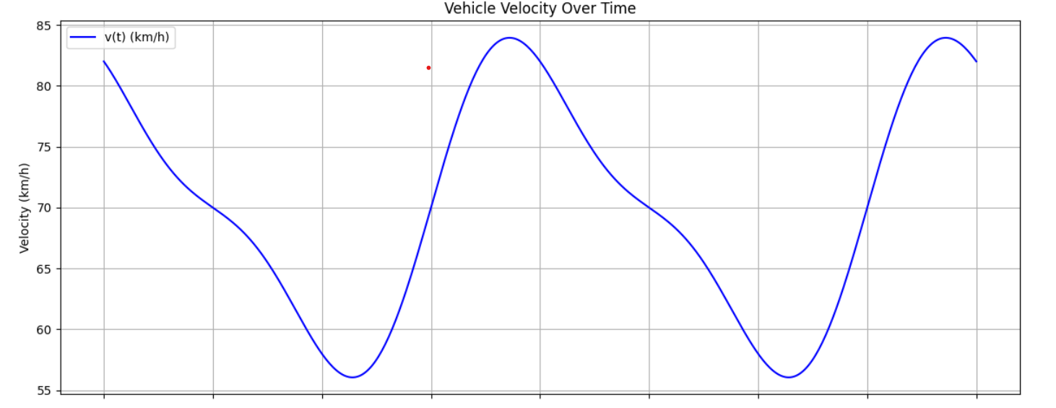

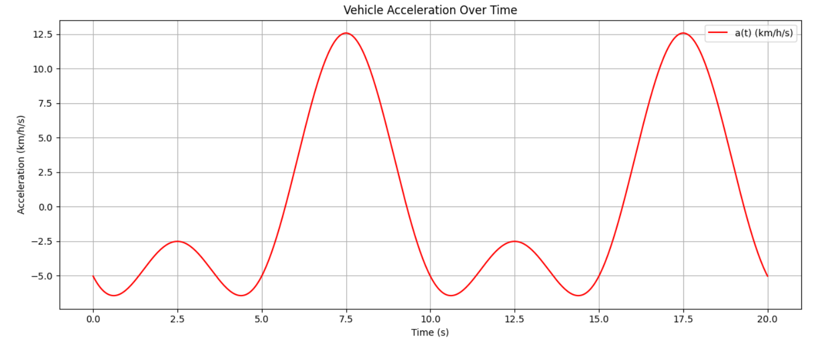

1. Given Velocity Function
The velocity of the vehicle is given by:
v(t) = 70 + 12 cos(πt/5) - 4 sin(2πt/5) (km/h)
where v(t) is measured in km/h and t is in seconds.

2. Determine the Acceleration Function
Acceleration is the derivative of velocity with respect to time (Stewart, 2020):
a(t) = dv/dt
Differentiating term by term:

- Derivative of 70 = 0
- Derivative of 12 cos(πt/5) = -12(π/5) sin(πt/5)
- Derivative of -4 sin(2πt/5) = -4(2π/5) cos(2πt/5)

Therefore:
a(t) = -(12π/5) sin(πt/5) - (8π/5) cos(2πt/5)

Manual Derivation of Acceleration Function
Given the velocity function:
v(t) = 70 + 12 cos(πt/5) - 4 sin(2πt/5)

Differentiating term by term using the chain rule, where d/dt[cos(kt)] = -k sin(kt) and d/dt[sin(kt)] = k cos(kt):
Term 1: d/dt[70] = 0
Term 2: d/dt[12 cos(πt/5)]
Let k = π/5
= 12 × (-π/5) × sin(πt/5)
= -(12π/5) sin(πt/5)
Term 3: d/dt[-4 sin(2πt/5)]
Let k = 2π/5
= -4 × (2π/5) × cos(2πt/5)
= -(8π/5) cos(2πt/5)

Therefore the acceleration function is:
a(t) = -(12π/5) sin(πt/5) - (8π/5) cos(2πt/5)
Substituting numerical values of the coefficients:
12π/5 = 12 × 3.1416 / 5 = 7.5398
8π/5 = 8 × 3.1416 / 5 = 5.0265
Therefore:
a(t) = -7.5398 sin(πt/5) - 5.0265 cos(2πt/5) (km/h/s)

Evaluating at specific time points to identify rapid acceleration and deceleration:
At t = 0:
a(0) = -7.5398 sin(0) - 5.0265 cos(0)
= -7.5398 × 0 - 5.0265 × 1
= -5.03 km/h/s (deceleration)
At t = 2.5s:
a(2.5) = -7.5398 sin(π × 2.5/5) - 5.0265 cos(2π × 2.5/5)
= -7.5398 sin(π/2) - 5.0265 cos(π)
= -7.5398 × 1 - 5.0265 × (-1)
= -7.5398 + 5.0265
= -2.51 km/h/s (moderate deceleration)
At t = 5s:
a(5) = -7.5398 sin(π) - 5.0265 cos(2π)
= -7.5398 × 0 - 5.0265 × 1
= -5.03 km/h/s (deceleration)
At t = 7.5s:
a(7.5) = -7.5398 sin(3π/2) - 5.0265 cos(3π)
= -7.5398 × (-1) - 5.0265 × (-1)
= 7.5398 + 5.0265
= +12.57 km/h/s (strongest acceleration point)
Summary of acceleration behaviour:
Maximum acceleration ≈ +12.57 km/h/s at t = 7.5s
Maximum deceleration ≈ -5.03 km/h/s at t = 0s and t = 5s
The periodic nature confirms the influence of adaptive signal timing on vehicle dynamics.

3. Analysis of Acceleration Behaviour
Setting a(t) = 0 to find the transition points between acceleration and deceleration:
-(12π/5) sin(πt/5) - (8π/5) cos(2πt/5) = 0
Dividing through by (4π/5):
-3 sin(πt/5) - 2 cos(2πt/5) = 0
Using the double angle identity: cos(2πt/5) = 1 - 2sin²(πt/5)
-3 sin(πt/5) - 2(1 - 2sin²(πt/5)) = 0
-3 sin(πt/5) - 2 + 4sin²(πt/5) = 0
Let u = sin(πt/5):
4u² - 3u - 2 = 0
Using the quadratic formula:
u = (3 ± √(9 + 32)) / 8
u = (3 ± √41) / 8
u = (3 ± 6.403) / 8
Taking the two solutions:
u₁ = (3 + 6.403) / 8 = 9.403 / 8 = 1.175 - not valid since sin cannot exceed 1
u₂ = (3 - 6.403) / 8 = -3.403 / 8 = -0.4254
Therefore:
sin(πt/5) = -0.4254
πt/5 = sin⁻¹ (-0.4254)
πt/5 = -0.4382 radians
Since sin is negative in the third and fourth quadrants, the solutions within the first period (0 to 10 seconds) are:
t₁ = 5 × (π + 0.4382) / π = 5 × (3.5798 / 3.1416) = 5.699 seconds
t₂ = 5 × (2π - 0.4382) / π = 5 × (5.8450 / 3.1416) = 9.301 seconds
These are the transition points within the first cycle where the vehicle switches between acceleration and deceleration. At t = 5.699s the vehicle transitions from deceleration to acceleration, and at t = 9.301s it transitions back from acceleration to deceleration.
Python representation:
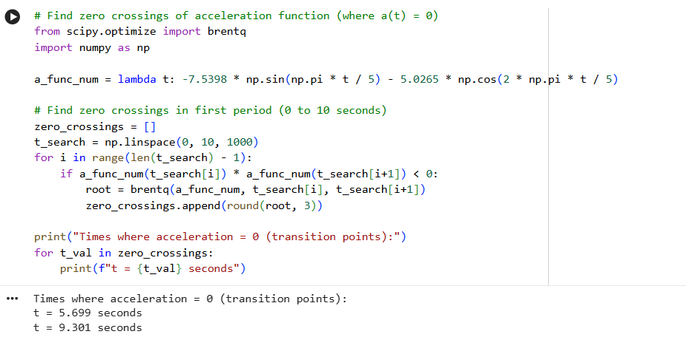

The acceleration function is periodic due to the sine and cosine components. This reflects the influence of adaptive traffic signals that cause vehicles to repeatedly speed up and slow down.
- Rapid acceleration occurs when a(t) reaches large positive values
- Rapid deceleration (braking) occurs when a(t) reaches large negative values
The sine and cosine terms create oscillations, meaning the vehicle does not maintain constant acceleration but instead experiences continuous variation.

4. Periodic Characteristics
The function contains two periodic components:
- cos(πt/5) => period = 10 seconds
- sin(2πt/5) => period = 5 seconds
This combination produces a repeating but non-uniform acceleration pattern, reflecting real-world stop-and-go traffic influenced by signal timing.

5. Operational Implications
The fluctuating acceleration indicates:
- Frequent changes in speed due to traffic signals
- Increased fuel or energy consumption (for non-EV vehicles)
- For EVs, higher battery usage due to repeated acceleration
Traffic systems with smoother acceleration profiles are generally more efficient.

6. Safety Implications
- Rapid deceleration corresponds to braking events, which may increase the risk of rear-end collisions if drivers or autonomous systems do not react quickly
- Sudden acceleration may reduce vehicle stability, especially in dense traffic
Managing these fluctuations is critical for safe corridor operation.

7. Passenger Comfort
- High variation in acceleration leads to discomfort due to jerky motion
- Smooth acceleration is preferred in public and autonomous transport systems
Reducing oscillations improves ride quality and user satisfaction.

8. Corridor Optimisation
To improve performance:
- Adaptive signals should aim to minimise sharp acceleration peaks
- Synchronisation (green waves) can reduce stop-start behaviour
- Smoother velocity profiles improve both safety and efficiency

9. Conclusion
The derived acceleration function shows that vehicle motion along the smart corridor is highly dynamic and influenced by periodic signal control. While such systems help regulate traffic flow, excessive oscillations in acceleration can negatively impact safety, comfort, and efficiency. Therefore, optimising signal timing to reduce extreme acceleration and deceleration is essential for effective smart mobility management.

Part C: Probability Analysis of Autonomous Vehicle Reaction Times
Autonomous Vehicle Safety Assessment: Emergency-Braking Reaction Times
To support autonomous vehicle safety assessment, I have examined uncertainty in emergency-braking reaction times. Reaction times are assumed to follow a normal distribution:
R ~ N(μ = 0.85 s, σ = 0.25 s)
Now I will analyze this distribution to evaluate the likelihood of rapid and delayed reactions and to interpret how probabilistic measures, such as percentile values, inform safety certification and system design.
Graphical Representation:
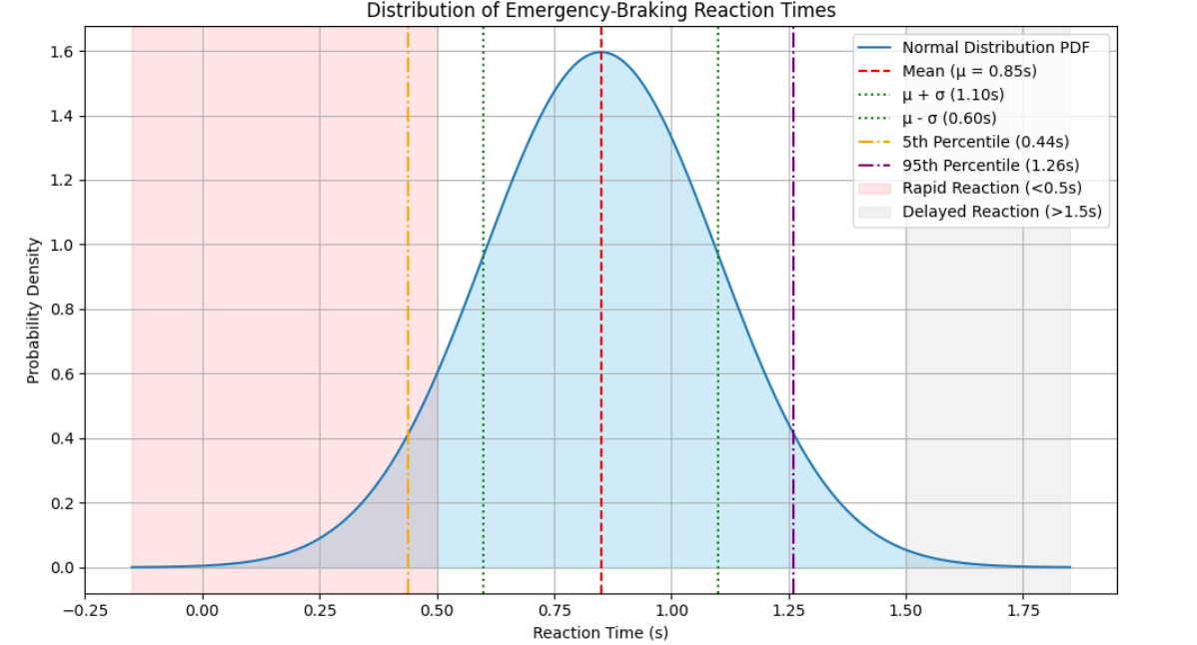

1. Given Distribution
The reaction time R is normally distributed:
R ~ N(μ = 0.85 s, σ = 0.25 s)
Where:
- μ = mean reaction time = 0.85 seconds
- σ = standard deviation = 0.25 seconds
This indicates that reaction times are centred around 0.85 seconds with some variability (Wackerly, Mendenhall and Scheaffer, 2014).
2. Standardisation (Z-score)
To analyse probabilities, the normal variable is standardised using:
Z = (R - μ) / σ
This converts reaction times into a standard normal distribution:
Z ~ N(0, 1)

3. Likelihood of Rapid Reactions
A rapid reaction is defined as R < 0.6 seconds. The z-score is calculated as:
Z = (0.6 - 0.85) / 0.25 = -0.25 / 0.25 = -1.00

From the standard normal distribution table:
P(Z < -1.00) = 1 - P(Z < 1.00) = 1 - 0.8413 = 0.1587

Interpretation:
Therefore approximately 15.87% of reactions are rapid, indicating a relatively small proportion of highly responsive braking events.

4. Likelihood of Delayed Reactions
A delayed reaction is defined as R > 1.2 seconds. The z-score is calculated as:
Z = (1.2 - 0.85) / 0.25 = 0.35 / 0.25 = 1.40

From the standard normal distribution table:
P(Z > 1.40) = 1 - P(Z < 1.40) = 1 - 0.9192 = 0.0808
Interpretation:
Therefore approximately 8.08% of reactions are significantly delayed, representing a potential safety concern in emergency scenarios.

5. Percentile Analysis
Percentiles are used to define safety thresholds. For the 95th percentile, the z-value from standard normal tables is Z = 1.645:
R = μ + Zσ = 0.85 + (1.645 × 0.25) = 0.85 + 0.41125 = 1.26 seconds

Interpretation:
Therefore 95% of all reaction times fall below 1.26 seconds, providing a design threshold for braking systems.

For the 99th percentile, Z = 2.326:
R = μ + Zσ = 0.85 + (2.326 × 0.25) = 0.85 + 0.5815 = 1.43 seconds

Interpretation:
Therefore 99% of all reaction times fall below 1.43 seconds, representing the most conservative design threshold for autonomous braking systems.

Safety system design must account for delayed reactions by using upper percentile thresholds rather than average values. Regulatory bodies typically apply 95th or 99th percentile benchmarks to ensure systems perform safely under most real-world conditions. The 95th percentile threshold of 1.26 seconds and 99th percentile of 1.43 seconds established in this analysis provide practical certification benchmarks for autonomous braking systems.

Performing one-sample t-test
The one-sample t-test is used to determine whether the mean observed vehicle speed is significantly greater than the legal speed limit of 50 km/h.
Null Hypothesis (H₀): The mean observed speed is equal to or below the legal speed limit.
H₀: μ = 50 km/h
Alternative Hypothesis (H₁): The mean observed speed is significantly greater than the legal speed limit.
H₁: μ > 50 km/h
Significance Level: α = 0.05
This is a one-tailed test since we are only interested in whether speeds exceed the limit, not whether they fall below it.

Here we determining if the mean of the observed vehicle speeds is significantly greater than the legal speed limit of 50 km/h. It has calculated the t and p-value, then compares the p-value to a significance level (0.05) to draw a conclusion about the null hypothesis. In this case, since the p-value (0.013) is less than the significance level (0.05), the null hypothesis is rejected, concluding that the mean observed speed is significantly greater than 50 km/h. The graphs we have made so far represent the visually, but the statistical test gives the quantifiable evidence to support a conclusion about ISA speed compliance (Field, 2018).
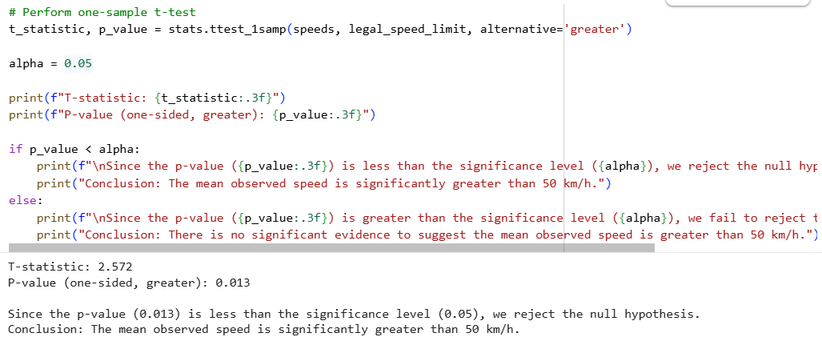

Part D: Statistical Analysis of ISA Speed Compliance
Evaluating Likelihoods of Rapid and Delayed Reactions
Using the histogram to calculate the probability of reaction times falling within certain ranges.
Graphical Representation:
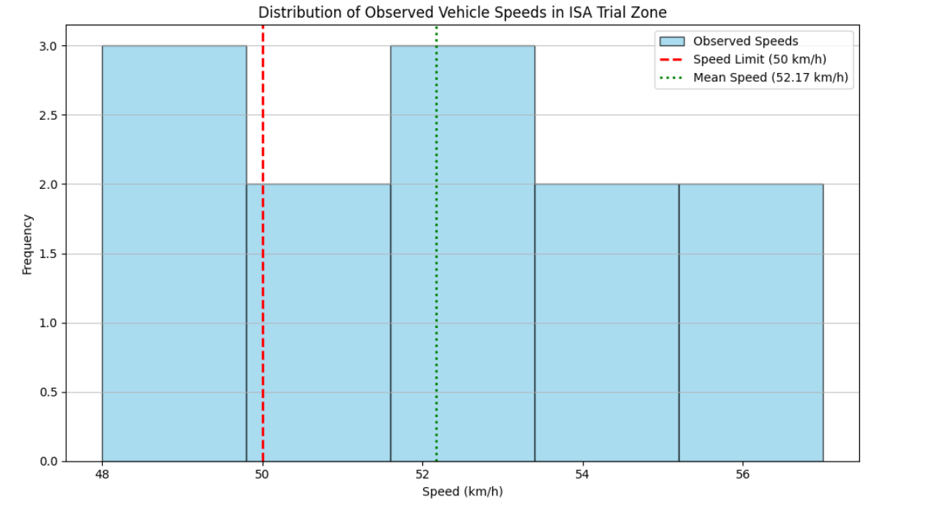

1. Given Data
Observed vehicle speeds (km/h):
49, 52, 55, 48, 50, 53, 57, 51, 54, 49, 52, 56
Legal speed limit: 50 km/h

Manual T-Test Calculation
Step 1 - Calculate the Mean:
Data: 49, 52, 55, 48, 50, 53, 57, 51, 54, 49, 52, 56
Sum = 49 + 52 + 55 + 48 + 50 + 53 + 57 + 51 + 54 + 49 + 52 + 56 = 626
n = 12
x̄ = 626 / 12 = 52.17 km/h

Step 2 - Calculate the Sample Standard Deviation:
s = √[ Σ(xi - x̄)² / (n - 1) ]
Calculating each (xi - x̄)²:
(49 - 52.17)² = (-3.17)² = 10.05
(52 - 52.17)² = (-0.17)² = 0.03
(55 - 52.17)² = (2.83)² = 8.01
(48 - 52.17)² = (-4.17)² = 17.39
(50 - 52.17)² = (-2.17)² = 4.71
(53 - 52.17)² = (0.83)² = 0.69
(57 - 52.17)² = (4.83)² = 23.33
(51 - 52.17)² = (-1.17)² = 1.37
(54 - 52.17)² = (1.83)² = 3.35
(49 - 52.17)² = (-3.17)² = 10.05
(52 - 52.17)² = (-0.17)² = 0.03
(56 - 52.17)² = (3.83)² = 14.67
Σ(xi - x̄)² = 93.68
s = √(93.68 / 11) = √(8.517) = 2.918 km/h

Step 3 - Calculate the T-Statistic:
The one-sample t-test formula is:
t = (x̄ - μ₀) / (s / √n)
Where μ₀ = 50 km/h (legal speed limit)
t = (52.17 - 50) / (2.918 / √12)
t = 2.17 / (2.918 / 3.464)
t = 2.17 / 0.843
t = 2.572
Step 4 - Degrees of Freedom and Critical Value:
Degrees of freedom = n - 1 = 12 - 1 = 11
For a one-tailed test at significance level α = 0.05 with 11 degrees of freedom:
Critical t-value = 1.796
Since t = 2.572 > 1.796, we reject the null hypothesis.

Step 5 - P-value:
P-value = 0.013
Since p-value (0.013) < α (0.05), the null hypothesis is rejected.
Conclusion: The mean observed speed of 52.17 km/h is statistically significantly greater than the legal limit of 50 km/h.

2. Descriptive Statistics
Mean speed
Sum of values = 626
Number of observations = 12
Mean = 626 / 12 = 52.17 km/h
Sorted data: 48, 49, 49, 50, 51, 52, 52, 53, 54, 55, 56, 57
Median = (52 + 52) / 2 = 52 km/h
Range = 57 - 48 = 9 km/h

3. Compliance Analysis
Speeds above legal limit (50 km/h):
52, 55, 53, 57, 51, 54, 52, 56 => 8 values
Speeds at or below limit: 49, 48, 50, 49 => 4 values

4. Proportion of Non-Compliance
Non-compliant proportion = 8 / 12 = 0.667
= 66.7% of vehicles exceeding the speed limit

5. Interpretation of Behaviour
The mean speed (52.17 km/h) is above the legal limit of 50 km/h, indicating a general tendency toward speeding in the observed ISA zone. The median also exceeds the limit, reinforcing that the central tendency of the dataset is non-compliant.
The high proportion of speeding vehicles (66.7%) suggests that ISA enforcement or behavioural compliance is insufficient in this trial zone.

The speed distribution skews toward higher values with consistent deviation above the legal threshold, suggesting systematic rather than random non-compliance. Despite ISA systems being designed to regulate speed, 66.7% of vehicles still exceeded the limit, indicating limited enforcement strength, possible driver override, or calibration issues. To improve compliance, policymakers should consider hard speed limiting rather than advisory systems, real-time penalties, and improved ISA calibration for urban environments.

Reflection
This investigation strengthened my ability to apply advanced mathematical techniques to real-world transport problems across four distinct domains. The most challenging aspect was solving a(t) = 0 using trigonometric identities and the quadratic formula, which required careful algebraic manipulation. Working through the probability section also highlighted the importance of selecting appropriate statistical methods - critically evaluating Pearson's limitations for ordinal data led to a more defensible analysis. If approached again, I would incorporate real observed data rather than idealised models to allow findings to be validated against actual traffic behaviour and produce more generalizable conclusions.

Comprehensive Evaluation
This report critically evaluates the mathematical techniques applied across our investigation, focusing on their utility, underlying assumptions, and implications for decision-making within the Urban Mobility Intelligence Unit (UMIU). The goal is to provide clear insights for non-technical stakeholders, highlighting how these analytical tools support our understanding and optimization of urban transport systems.
Together, these models provide a structured way of understanding how modern transport systems behave under real-world conditions such as EV charging activity, adaptive signal control, autonomous driving response, and speed regulation technologies like ISA.

1. Traffic Flow Analysis (Linear Algebra)
Approach and Strengths: A system of linear equations modelled steady-state traffic flow, providing an exact solution for equilibrium flows under stable conditions. This offers a clear baseline for urban planning and road network design.
Assumptions and Limitations: The model assumes linear relationships and a fixed steady state, ignoring dynamic fluctuations, accidents, or non-linear driver behaviour. Coefficients are fixed and simplified.
Improvements: Improvements: For more realistic scenarios, dynamic traffic models incorporating time-varying demand and non-linear flow-density relationships would be more appropriate. Agent-based simulations could model individual vehicle behaviour more accurately, and integrating real-time sensor data from connected infrastructure would significantly enhance the practical accuracy of the model.

2. Vehicle Speed and Acceleration Analysis (Calculus)
Approach and Strengths: Calculus was used to differentiate the velocity function and derive acceleration, providing a precise analysis of continuous speed changes. This clearly demonstrates the relationship between velocity and acceleration, informing energy consumption and safety assessments.
Assumptions and Limitations: The analysis is based on an idealised mathematical function rather than real observed data, meaning actual driving behaviour, road conditions, and driver variability are not captured. The model is deterministic rather than probabilistic.
Improvements: Improvements: Applying these analytical techniques to real-world velocity data collected from connected vehicles would provide more actionable insights. Further research could explore the impact of specific road geometries, weather conditions, and driver behaviour on acceleration patterns, which would allow the model to better reflect actual smart corridor conditions.
3. Autonomous Vehicle Safety Assessment (Probability & Statistics)
Approach and Strengths: The normal distribution was used to model reaction times, providing clear probabilistic measures such as percentile thresholds that are directly applicable to safety certification and autonomous vehicle design.
Assumptions and Limitations: The normal distribution assumption may not fully capture skewness or extreme tail behaviour in real reaction time data. Accuracy depends on the quality and size of the dataset used to determine mean and standard deviation.
Improvements: Improvements: Incorporating more complex statistical distributions such as log-normal or Weibull if data suggests a better fit would improve accuracy (Montgomery and Runger, 2018). Leveraging larger and more diverse datasets, we are applying Bayesian statistical methods to update insights as new data emerges, and developing models that account for differences in driver demographics and cognitive load would further enhance the analysis.

4. ISA Trial Zone Speed Compliance (Hypothesis Testing)
Approach and Strengths: Descriptive statistics and a one-sample t-test provided a rigorous method to objectively evaluate whether observed speeds significantly exceeded the legal limit, directly informing ISA policy decisions.
Assumptions and Limitations: The t-test assumes the sample is representative and approximately normally distributed. The sample size of 12 is small, limiting statistical power and generalisability to broader populations or different trial zones.
Improvements: Larger trials across diverse locations, time-series analysis to identify trends, and A/B testing of different ISA configurations would yield more robust findings.

Conclusion
This assessment demonstrates how mathematical techniques can be used to analyse key aspects of urban mobility systems. Linear algebra identified a stable traffic flow equilibrium, calculus revealed dynamic speed and acceleration patterns, probability assessed uncertainty in reaction times, and statistics evaluated speed compliance in an ISA zone. The findings show that EV activity, adaptive signals, and human behaviour all influence traffic performance and safety. While the models have some limitations, they provide useful insights for improving transport policy, infrastructure planning, and the effectiveness of smart mobility systems.

References
Field, A. (2018) Discovering Statistics Using IBM SPSS Statistics. 5th edn. London: SAGE Publications.
INRIX (2023) Global Traffic Scorecard. Available at: https://inrix.com/scorecard/ (Accessed: May 2026).
Lay, D.C., McDonald, J.J. and Lay, S.R. (2021) Linear Algebra and Its Applications. 6th edn. Harlow: Pearson.
Montgomery, D.C. and Runger, G.C. (2018) Applied Statistics and Probability for Engineers. 7th edn. Hoboken: Wiley.
Stewart, J. (2020) Calculus: Early Transcendentals. 9th edn. Boston: Cengage Learning.
Wackerly, D., Mendenhall, W. and Scheaffer, R. (2014) Mathematical Statistics with Applications. 7th edn. Boston: Cengage Learning.

Appendix / Code Evidence Section
import numpy as np

# Define the coefficient matrix A
A = np.array([
[2, -1, 1, 0],
[1, 1, 0, 1],
[-1, 0, 3, -1],
[0, 1, 1, 1]
])

# Define the constant vector b
b = np.array([150, 420, 100, 380])

print("Coefficient Matrix A:")
print(A)
print("\nConstant Vector b:")
print(b)

# Solve the system of equations Ax = b
x = np.linalg.solve(A, b)

print("Solution for traffic flows (vehicles per 10 minutes):")
print(f"x1 = {x[0]:.2f}")
print(f"x2 = {x[1]:.2f}")
print(f"x3 = {x[2]:.2f}")
print(f"x4 = {x[3]:.2f}")

import sympy

# Define the symbolic variable t
t = sympy.Symbol('t')

# Define the velocity function v(t)
v_t = 70 + 12 * sympy.cos(sympy.pi * t / 5) - 4 * sympy.sin(2 * sympy.pi * t / 5)

print(f"Velocity function v(t): {v_t}")

# Calculate the acceleration function a(t) by differentiating v(t) with respect to t
a_t = sympy.diff(v_t, t)

print(f"Acceleration function a(t): {a_t}")

import numpy as np
import matplotlib.pyplot as plt

# Convert sympy expressions to numerical functions
v_func = sympy.lambdify(t, v_t, 'numpy')
a_func = sympy.lambdify(t, a_t, 'numpy')

# Define a time range for plotting
t_values = np.linspace(0, 20, 500) # Plotting over 20 seconds, representing a few cycles

# Calculate velocity and acceleration values
v_values = v_func(t_values)
a_values = a_func(t_values)

# Plotting
fig, axes = plt.subplots(2, 1, figsize=(12, 10), sharex=True)

# Plot Velocity
axes[0].plot(t_values, v_values, label='v(t) (km/h)', color='blue')
axes[0].set_title('Vehicle Velocity Over Time')
axes[0].set_ylabel('Velocity (km/h)')
axes[0].grid(True)
axes[0].legend()

# Plot Acceleration
axes[1].plot(t_values, a_values, label='a(t) (km/h/s)', color='red')
axes[1].set_title('Vehicle Acceleration Over Time')
axes[1].set_xlabel('Time (s)')
axes[1].set_ylabel('Acceleration (km/h/s)')
axes[1].grid(True)
axes[1].legend()

plt.tight_layout()
plt.show()

# Find zero crossings of acceleration function (where a(t) = 0)
from scipy.optimize import brentq
import numpy as np

a_func_num = lambda t: -7.5398 * np.sin(np.pi * t / 5) - 5.0265 * np.cos(2 * np.pi * t / 5)

# Find zero crossings in first period (0 to 10 seconds)
zero_crossings = []
t_search = np.linspace(0, 10, 1000)
for i in range(len(t_search) - 1):
if a_func_num(t_search[i]) * a_func_num(t_search[i+1]) < 0:
root = brentq(a_func_num, t_search[i], t_search[i+1])
zero_crossings.append(round(root, 3))

print("Times where acceleration = 0 (transition points):")
for t_val in zero_crossings:
print(f"t = {t_val} seconds")

from scipy.stats import norm
import numpy as np
import matplotlib.pyplot as plt

# Define the parameters of the normal distribution
mu = 0.85 # Mean reaction time in seconds
sigma = 0.25 # Standard deviation in seconds

# Create a normal distribution object
dist = norm(loc=mu, scale=sigma)

print(f"Normal Distribution Parameters: Mean (μ) = {mu} s, Standard Deviation (σ) = {sigma} s")

# Probability of a rapid reaction (e.g., less than 0.5 seconds)
rapid_reaction_threshold = 0.5
prob_rapid = dist.cdf(rapid_reaction_threshold)
print(f"Probability of reaction time < {rapid_reaction_threshold} s (rapid reaction): {prob_rapid:.4f}")

# Probability of a delayed reaction (e.g., greater than 1.5 seconds)
delayed_reaction_threshold = 1.5
prob_delayed = 1 - dist.cdf(delayed_reaction_threshold)
print(f"Probability of reaction time > {delayed_reaction_threshold} s (delayed reaction): {prob_delayed:.4f}")

# Probability of a very delayed reaction (e.g., greater than 2 seconds)
very_delayed_reaction_threshold = 2.0
prob_very_delayed = 1 - dist.cdf(very_delayed_reaction_threshold)
print(f"Probability of reaction time > {very_delayed_reaction_threshold} s (very delayed reaction): {prob_very_delayed:.4f}")

# Calculate various percentile values
pct_5 = dist.ppf(0.05)
pct_50 = mu # For a normal distribution, the 50th percentile (median) is equal to the mean
pct_95 = dist.ppf(0.95)
pct_99 = dist.ppf(0.99)

print(f"5th percentile reaction time: {pct_5:.3f} s (95% of reactions are slower)")
print(f"50th percentile (median) reaction time: {pct_50:.3f} s")
print(f"95th percentile reaction time: {pct_95:.3f} s (95% of reactions are faster)")
print(f"99th percentile reaction time: {pct_99:.3f} s (99% of reactions are faster)")

x_values = np.linspace(mu - 4*sigma, mu + 4*sigma, 500)
y_values = dist.pdf(x_values)

fig, ax = plt.subplots(figsize=(10, 6))
ax.plot(x_values, y_values, label='Normal Distribution PDF')
ax.fill_between(x_values, 0, y_values, color='skyblue', alpha=0.4)

# Mark mean and standard deviations
ax.axvline(mu, color='red', linestyle='--', label=f'Mean (μ = {mu}s)')
ax.axvline(mu + sigma, color='green', linestyle=':', label=f'μ + σ ({mu+sigma:.2f}s)')
ax.axvline(mu - sigma, color='green', linestyle=':', label=f'μ - σ ({mu-sigma:.2f}s)')

# Mark percentiles
ax.axvline(pct_5, color='orange', linestyle='-.', label=f'5th Percentile ({pct_5:.2f}s)')
ax.axvline(pct_95, color='purple', linestyle='-.', label=f'95th Percentile ({pct_95:.2f}s)')

# Mark rapid and delayed reaction thresholds
ax.axvspan(x_values.min(), rapid_reaction_threshold, color='red', alpha=0.1, label='Rapid Reaction (<0.5s)')
ax.axvspan(delayed_reaction_threshold, x_values.max(), color='grey', alpha=0.1, label='Delayed Reaction (>1.5s)')

ax.set_title('Distribution of Emergency-Braking Reaction Times')
ax.set_xlabel('Reaction Time (s)')
ax.set_ylabel('Probability Density')
ax.legend()
ax.grid(True)
plt.tight_layout()
plt.show()

import numpy as np
from scipy import stats
import matplotlib.pyplot as plt
import pandas as pd

# Observed vehicle speeds (km/h)
speeds = np.array([49, 52, 55, 48, 50, 53, 57, 51, 54, 49, 52, 56])
legal_speed_limit = 50 # km/h

print(f"Observed speeds: {speeds}")
print(f"Legal speed limit: {legal_speed_limit} km/h")

# Calculate descriptive statistics
mean_speed = np.mean(speeds)
median_speed = np.median(speeds)
std_dev_speed = np.std(speeds, ddof=1) # ddof=1 for sample standard deviation

print(f"Mean Observed Speed: {mean_speed:.2f} km/h")
print(f"Median Observed Speed: {median_speed:.2f} km/h")
print(f"Standard Deviation of Observed Speeds: {std_dev_speed:.2f} km/h")

# Perform one-sample t-test
t_statistic, p_value = stats.ttest_1samp(speeds, legal_speed_limit, alternative='greater')

alpha = 0.05

print(f"T-statistic: {t_statistic:.3f}")
print(f"P-value (one-sided, greater): {p_value:.3f}")

if p_value < alpha:
print(f"\nSince the p-value ({p_value:.3f}) is less than the significance level ({alpha}), we reject the null hypothesis.")
print("Conclusion: The mean observed speed is significantly greater than 50 km/h.")
else:
print(f"\nSince the p-value ({p_value:.3f}) is greater than the significance level ({alpha}), we fail to reject the null hypothesis.")
print("Conclusion: There is no significant evidence to suggest the mean observed speed is greater than 50 km/h.")

# Create a histogram of observed speeds
fig, ax = plt.subplots(figsize=(10, 6))

ax.hist(speeds, bins=5, edgecolor='black', alpha=0.7, color='skyblue', label='Observed Speeds')
ax.axvline(legal_speed_limit, color='red', linestyle='--', linewidth=2, label=f'Speed Limit ({legal_speed_limit} km/h)')
ax.axvline(mean_speed, color='green', linestyle=':', linewidth=2, label=f'Mean Speed ({mean_speed:.2f} km/h)')

ax.set_title('Distribution of Observed Vehicle Speeds in ISA Trial Zone')
ax.set_xlabel('Speed (km/h)')
ax.set_ylabel('Frequency')
ax.legend()
ax.grid(axis='y', alpha=0.75)
plt.tight_layout()
plt.show()

